**Par A: Explore the Frequency Domain - Discrete Fourier Transform**

1. Use the dft example we went over in class to generate the magnitude spectrum of the frequency domain for a set of provided input images.

**You can find this code in your opencv installation** as executable binary example_cpp_dft. The source code is in samples/cpp/dft.cpp for you to copy and modify. You will find a folder of **sample input files** to use posted on Canvas with this assignment.

**Observe the output. There is nothing to submit but you can expect questions on the Midterm asking you to identify corresponding pairs of similar images and to comment on characteristics.** This is one tool to study it.

1. Copy and modify the source code to display both the spatial domain and frequency domain spectra side by side and answer the following questions.
2. Which images have spectra that exhibit distinct characteristics that you can easily identify in the spatial domain?

The graypattern image has spectra that shows distinct characteristics as below. As we can see that there are two axis, horizontal and vertical. The axis suggests that there are significant color changes between light and dark horizontally and vertically. Spectra from other images does not reproduce patterns like this.

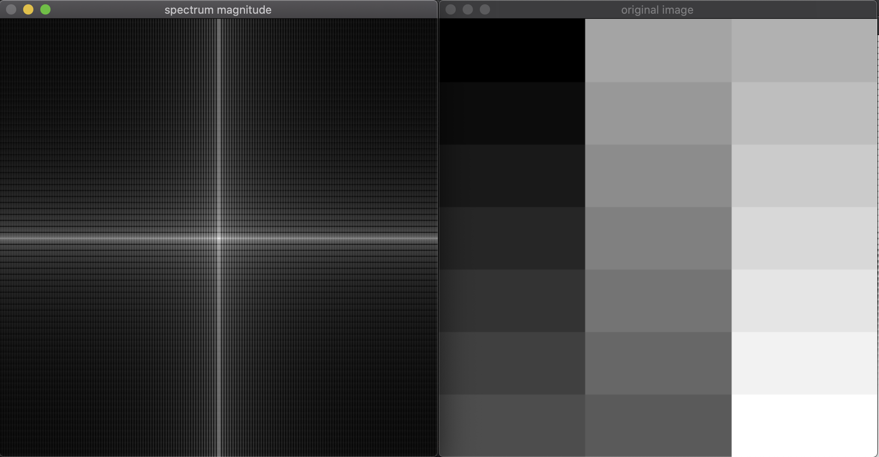

1. Which images have spectra without distinct characteristics, in your opinion?

In my opinion, the flowergray image does not have distinct characteristics. There is only one bright white dot in the center.

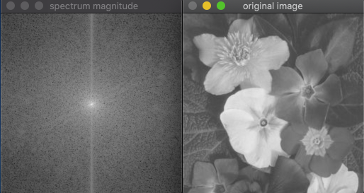

1. Choose three pairs with distinct characteristics to include here with a screen shot. Annotate the screen shots with marking and notes to describe what you see and where the correspondence is.

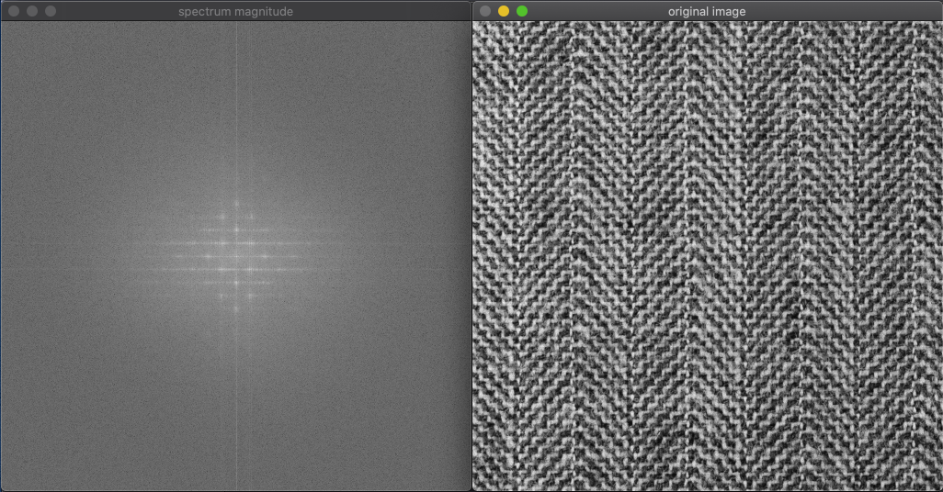As we can see, there are several white dots around the center of the image. This indicates that there are many duplicated patterns in the image.

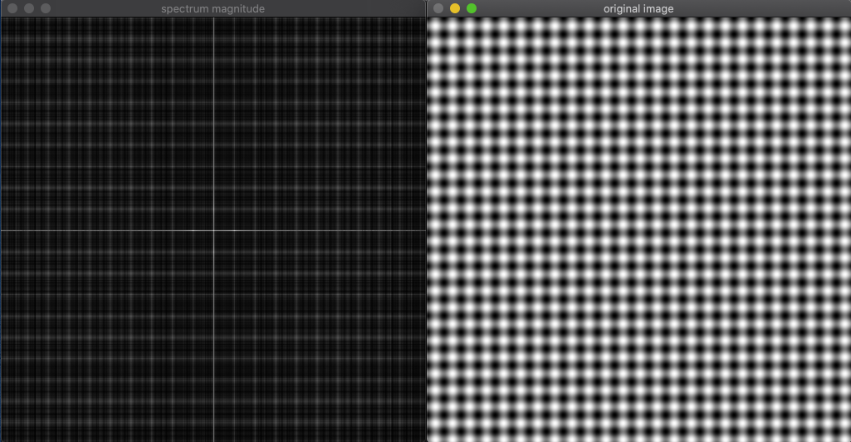Same as the last image, there are many white dots on the image. This indicates that there are many duplicated patterns in the image. There are straight axis vertically and horizontally shows that the changes in light and dark color in the original image.

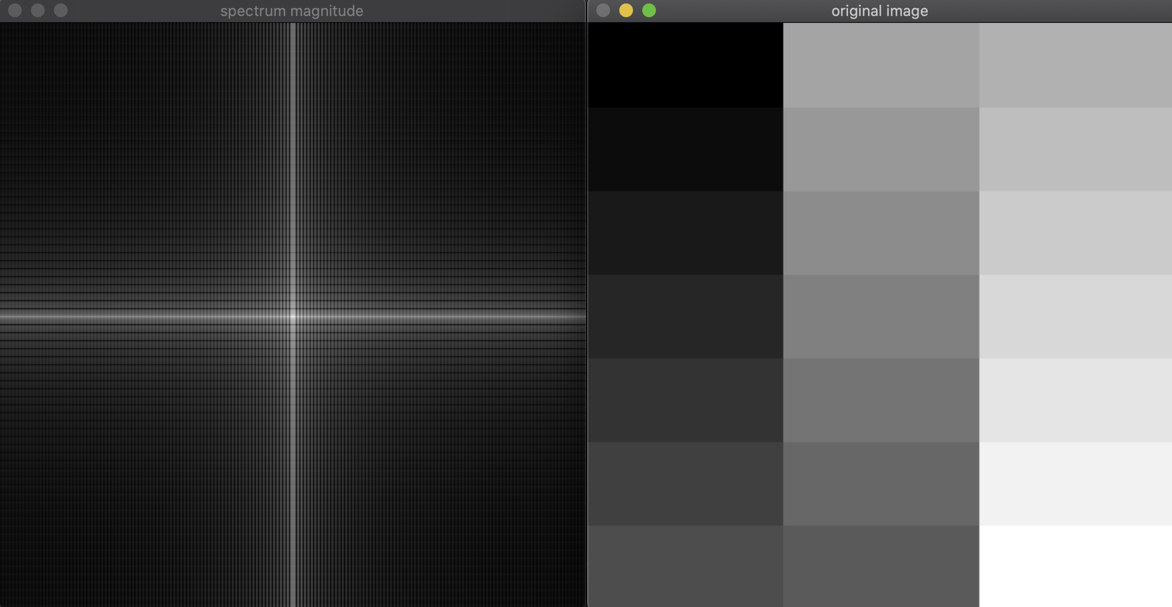

There are two axis, horizontal and vertical. The axis suggests that there are significant color changes between light and dark horizontally and vertically. The color gets darker farther out from the center and it means higher frequency of the function.

1. Modify the code to ALSO visual the phase for each image. You can find a function in opencv to compute the phase.

Search opencv modules here for function phase: <https://docs.opencv.org/master/modules.html>

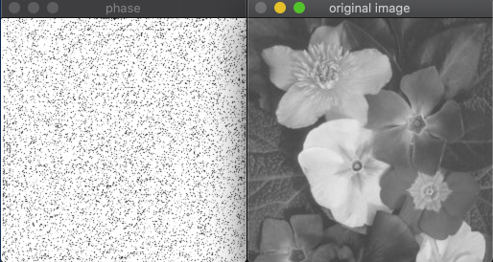

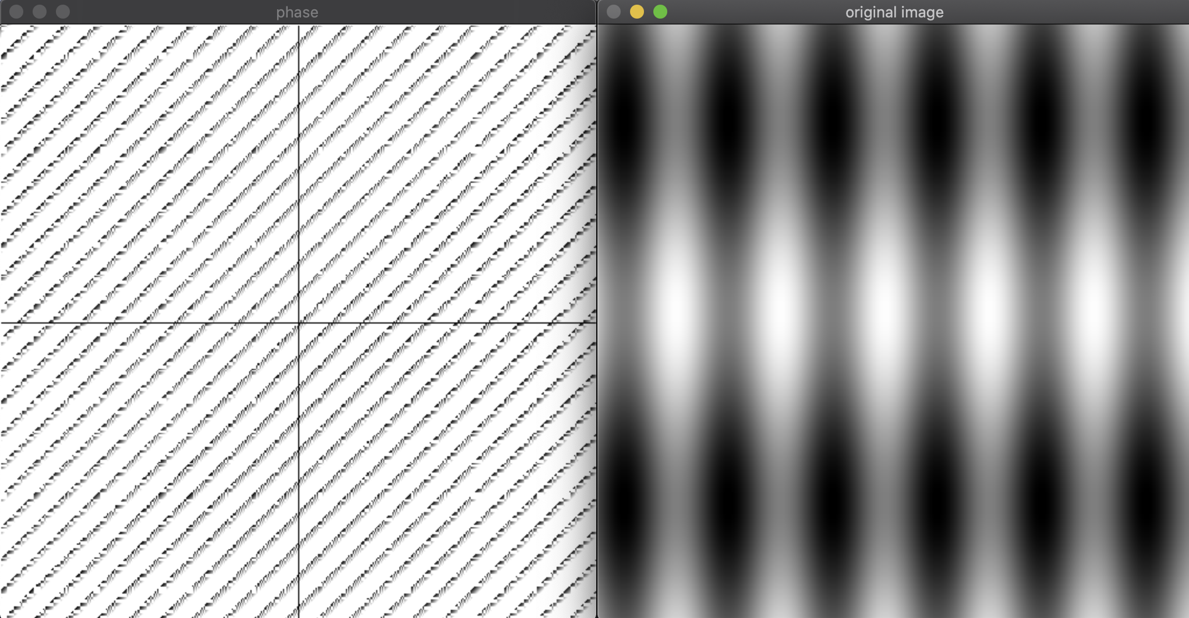

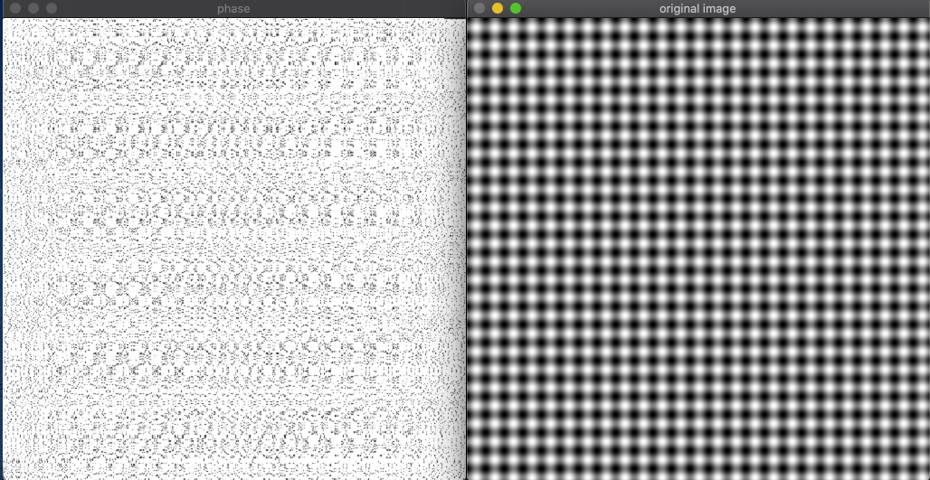

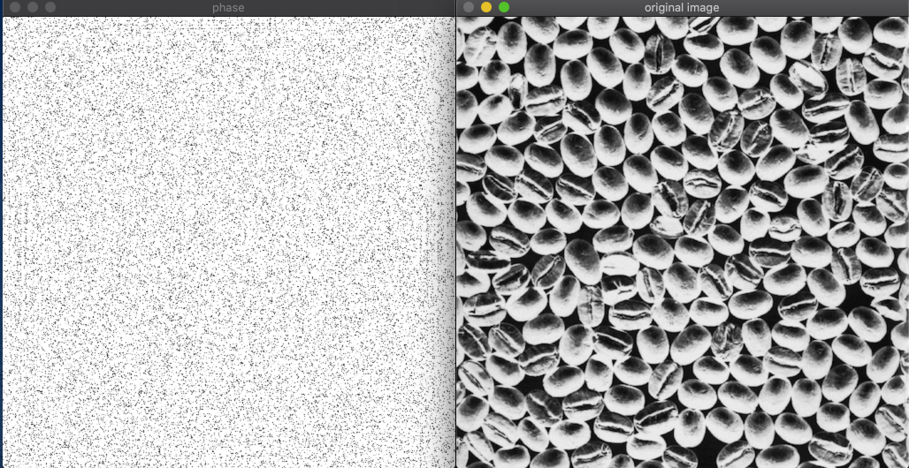

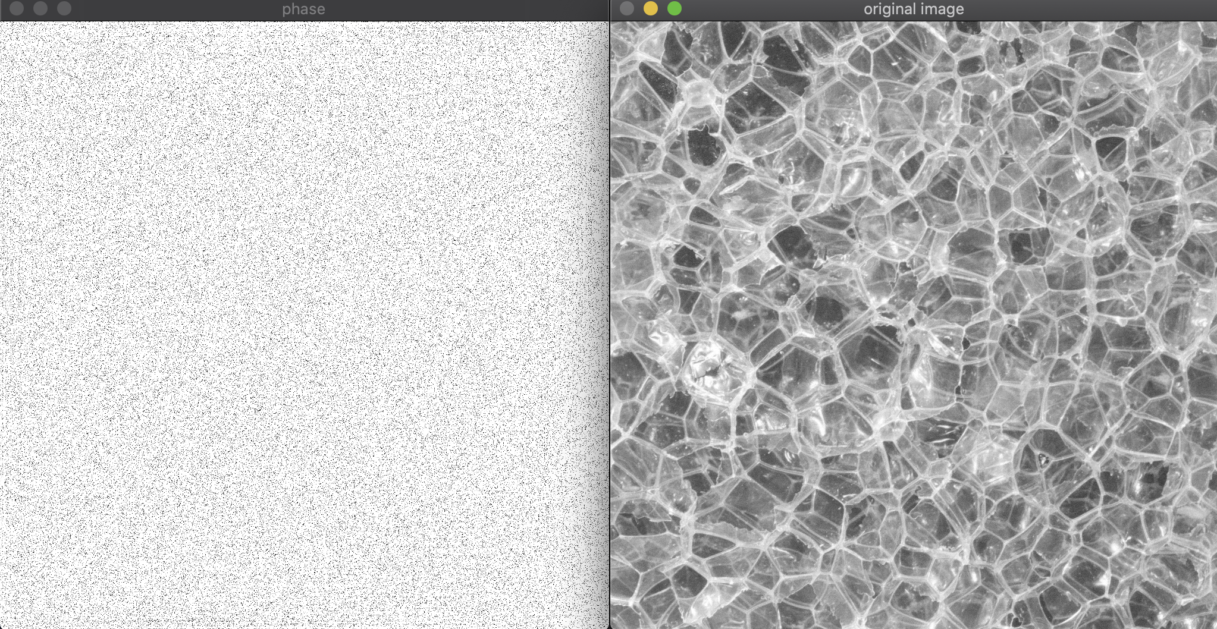

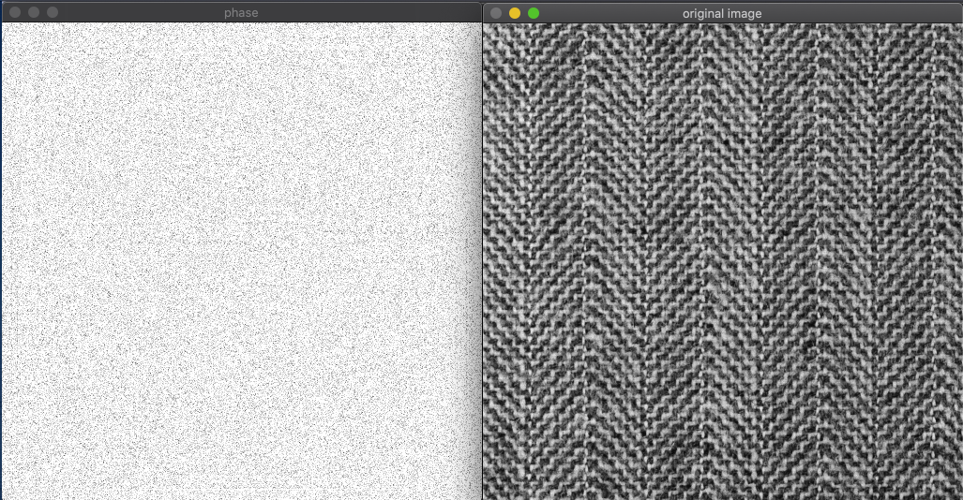

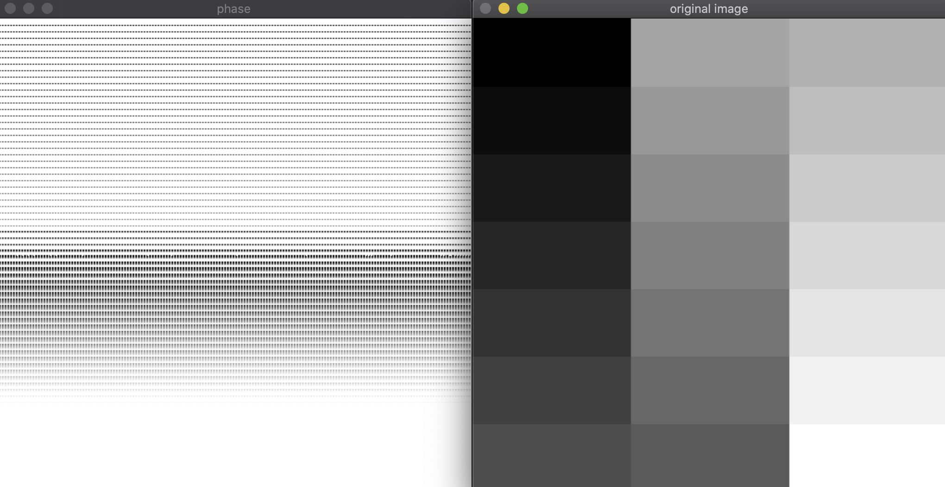

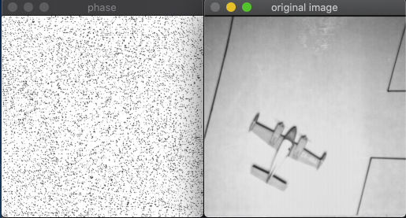

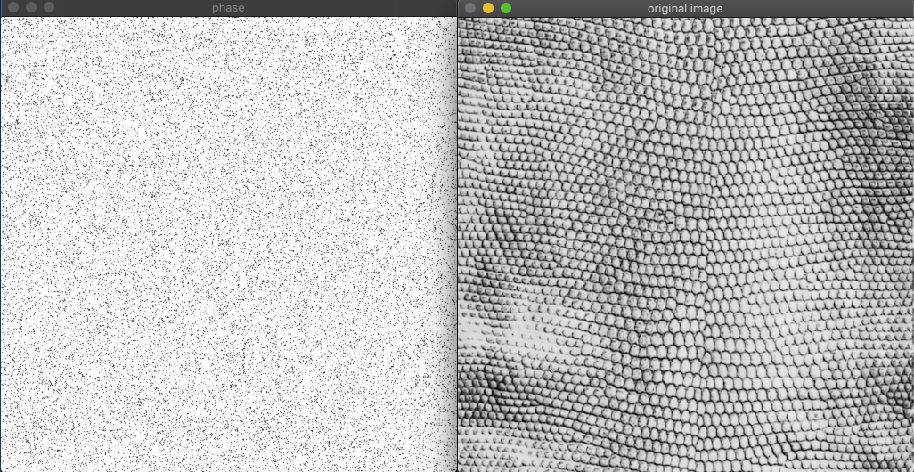

(a) What include file do you need to have in order to use this method? (HINT: you can find that in the documentation for each function.)

core.hpp

(b) Include a screenshot of the phase for each of the image your described in (4) above. Please clearly mark which phase image goes with each spatial domain image.

I am a bit confused because in (4) we are allowed to choose whatever image we think is without distinct characteristics, and I think there are more than 1 images that fulfill with (4)’s requirements, so I attached all phase images below.

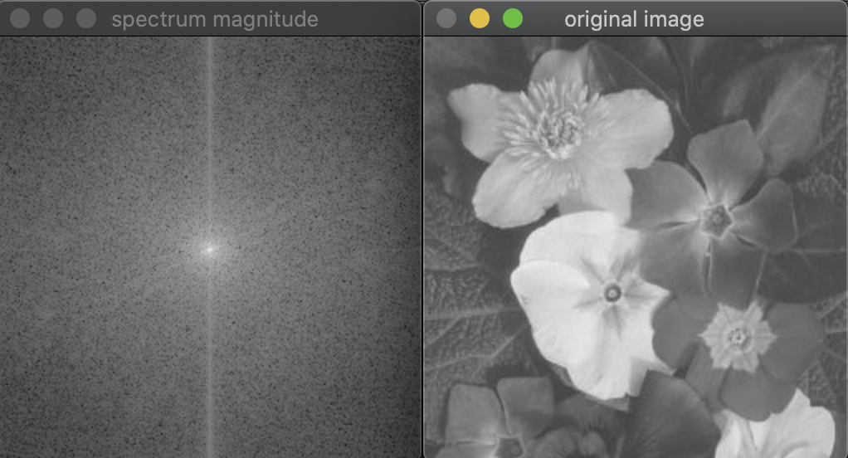

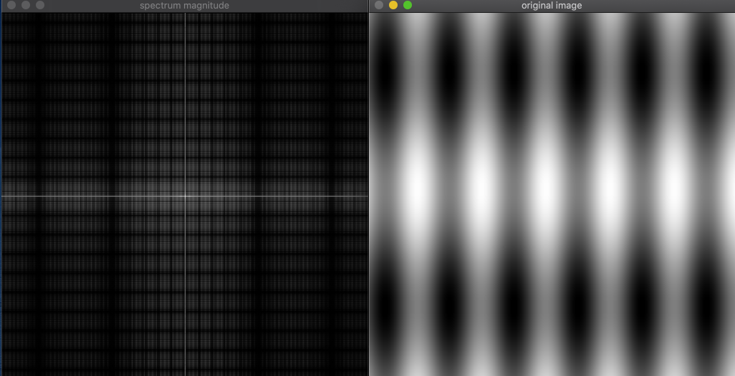

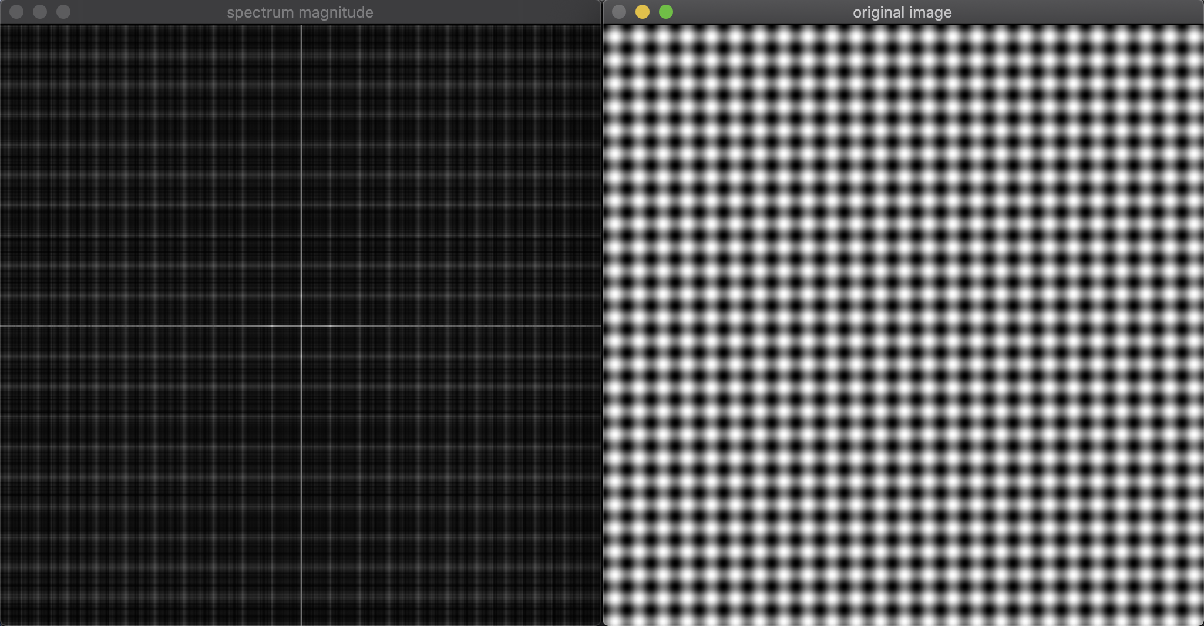

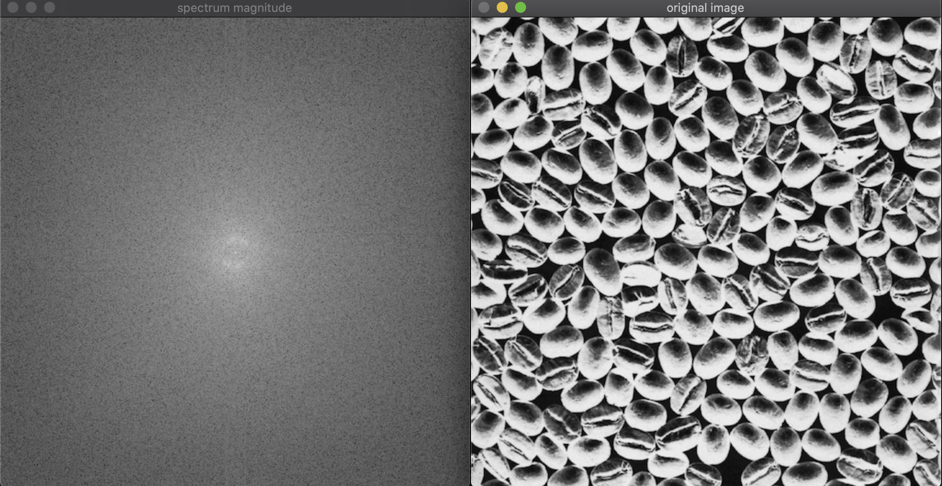

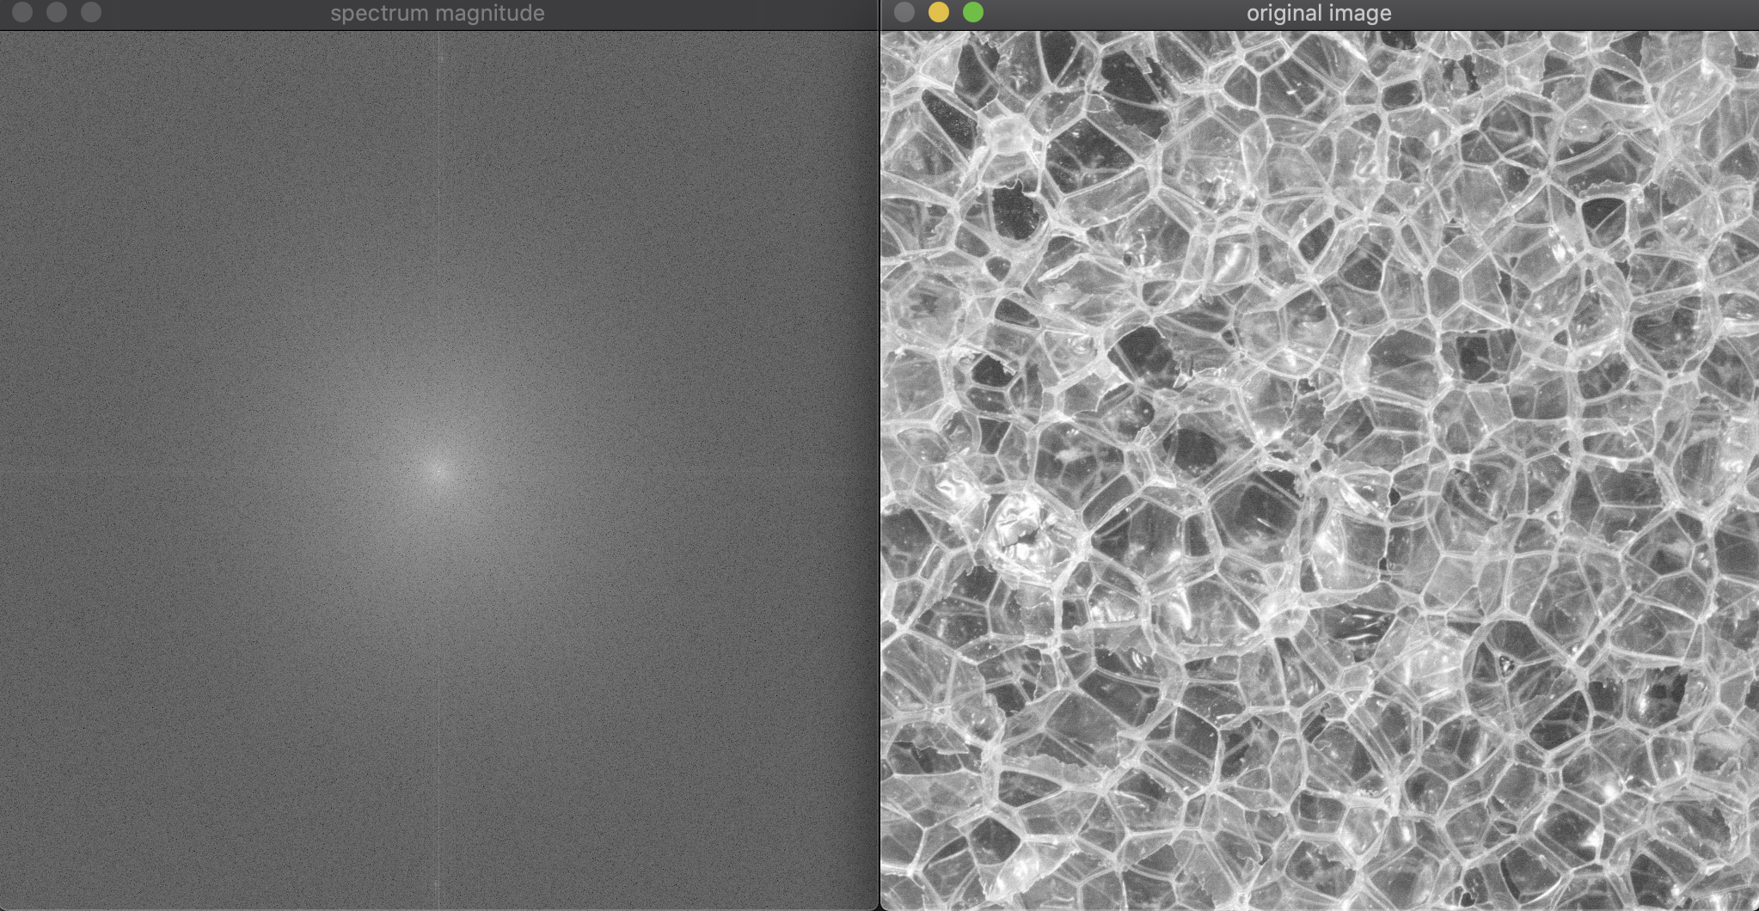

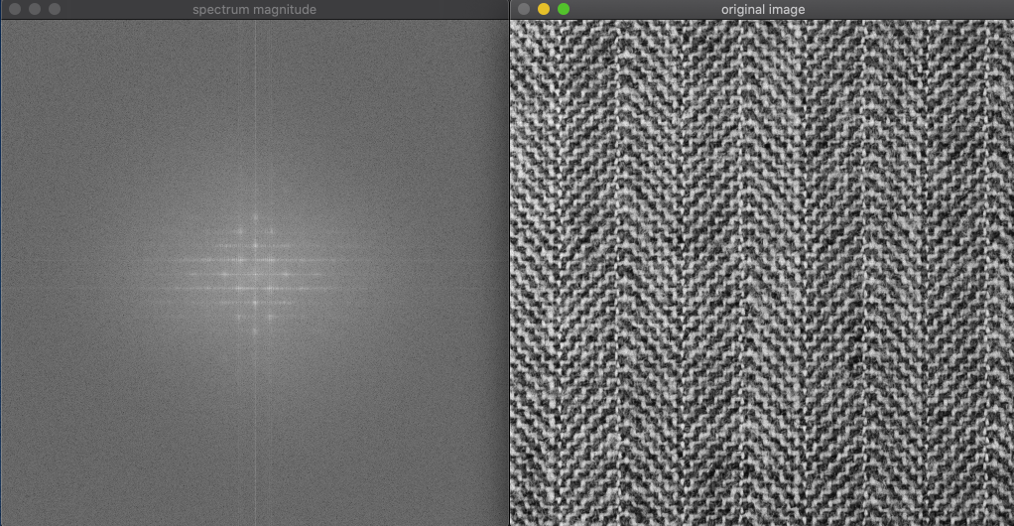

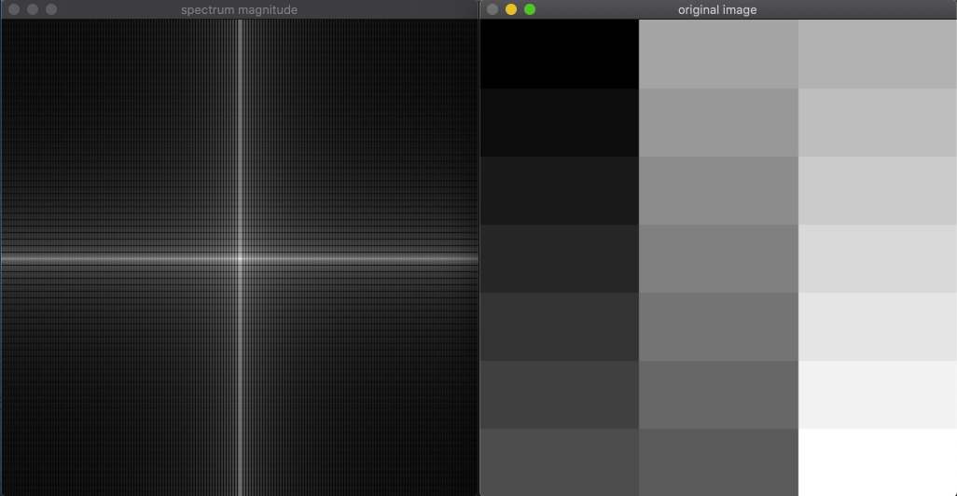

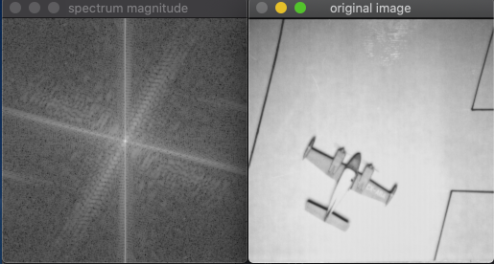

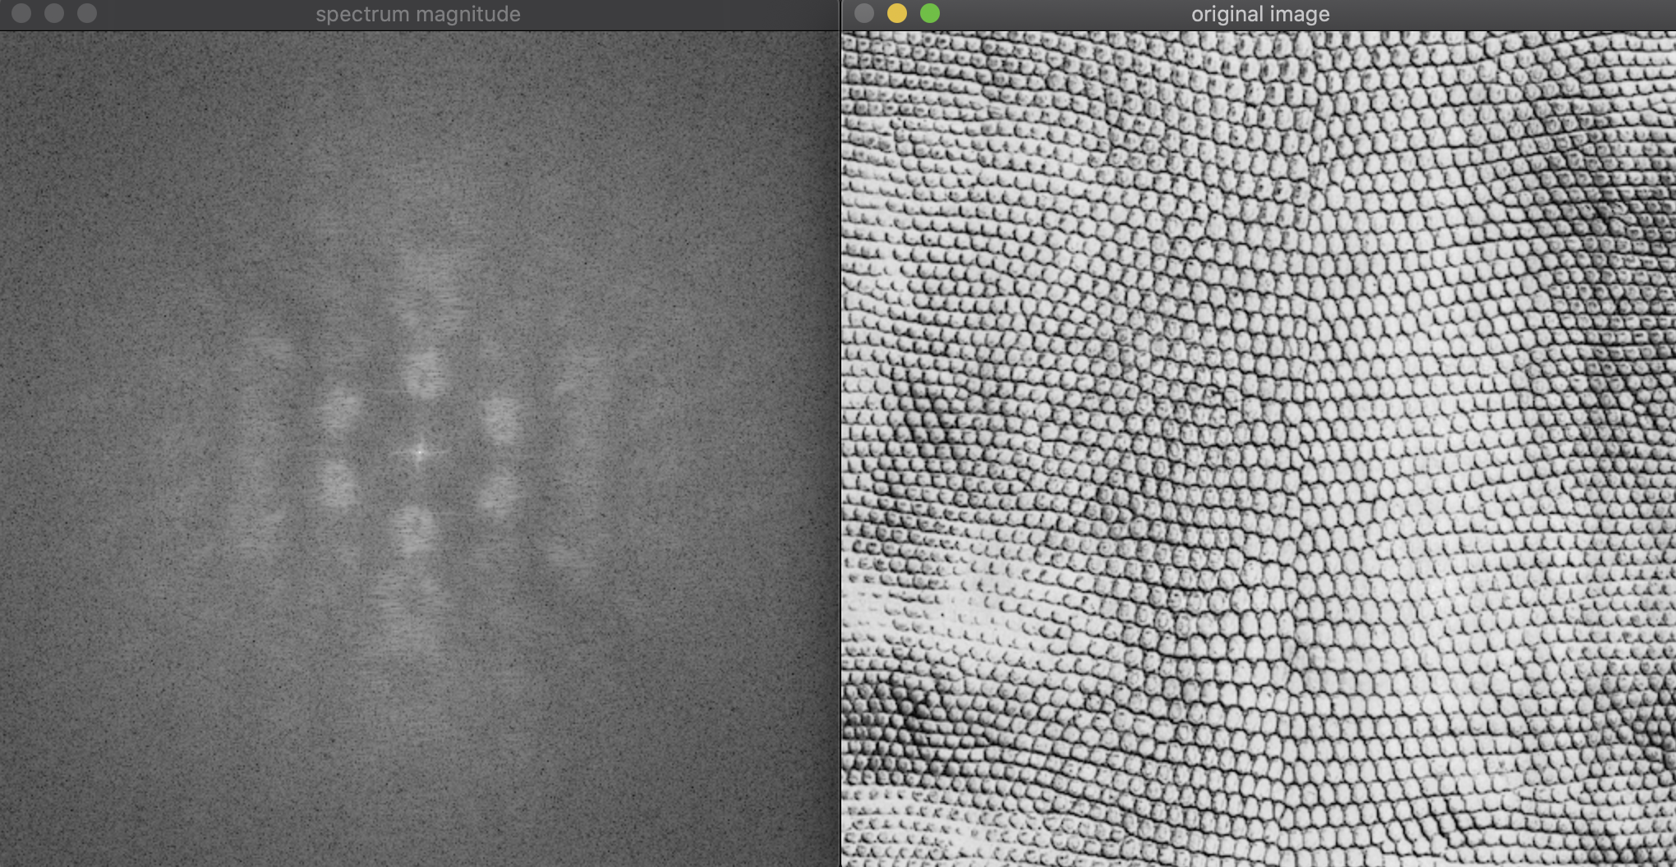

1. Create a 256x256 grayscale image using random noise. Compute its magnitude spectrum and include a screen shot here.

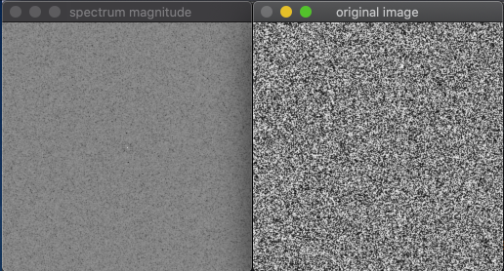

1. Describe the spectrum from (7). How can you account for its appearance?

Like the original image, the spectrum looks very noisy. There is no many characteristics.

1. Use your SineWaveExplorer program from HW2 to create and save a grayscale image file. Use the DFT program here to compute and display its magnitude spectrum. Include a screen shot of the spatial domain and frequency domain here. Also include the SineWave file itself.

